### **Dashboard / Home Page**

Dashboard or Home Page for different user roles



Written By Ivan Karmer

Updated 2 years ago

The user is landed in the Dashboard or Home Page as soon as the user login to the system.

Each user role (like Admin, Parent, Student, Instructor, etc) has a different dashboard.

When an Admin login to the system, following information displays -

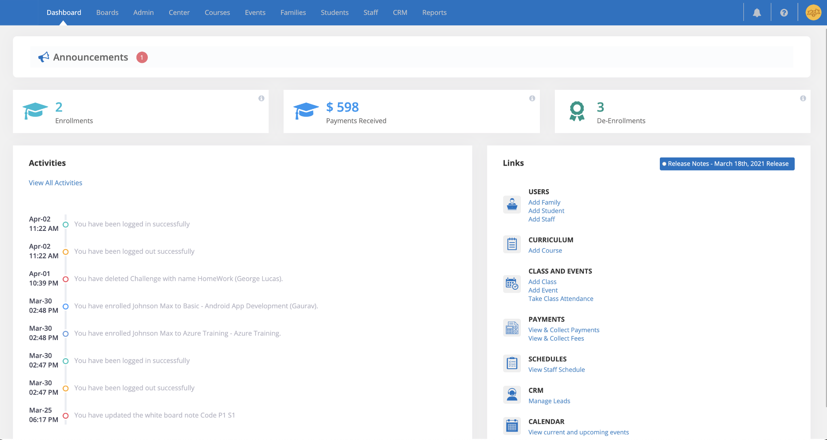

**Announcements**

The announcements are displayed based on the announcement settings like "Expand by Default", "User Role", "Franchise/Center", etc.

This section acts as a Notice Board to the Parents, Students, Instructors, etc.

**Metrics or Counters**

A quick summary of high level information is displayed based on the user role (Admin, Parent, Student, etc).

For example, following Metrics or Counters are displayed for Students & Parents -

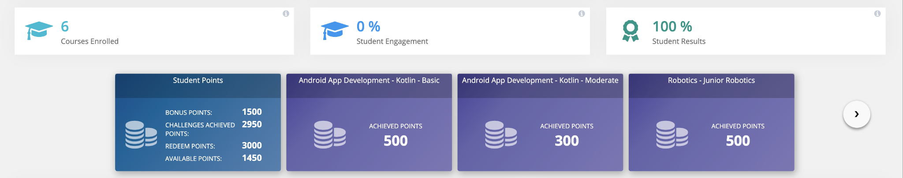

**Activities**

List of activities performed by the user are displayed here.

**Links**

Based on the type of the user, the list of Quick links are displayed here.

Example - For Student, the quick links related to the Student are displayed. Like

a) Joining an Online Class

b) Viewing the Student's White Board

c) Taking their Assessments

etc.

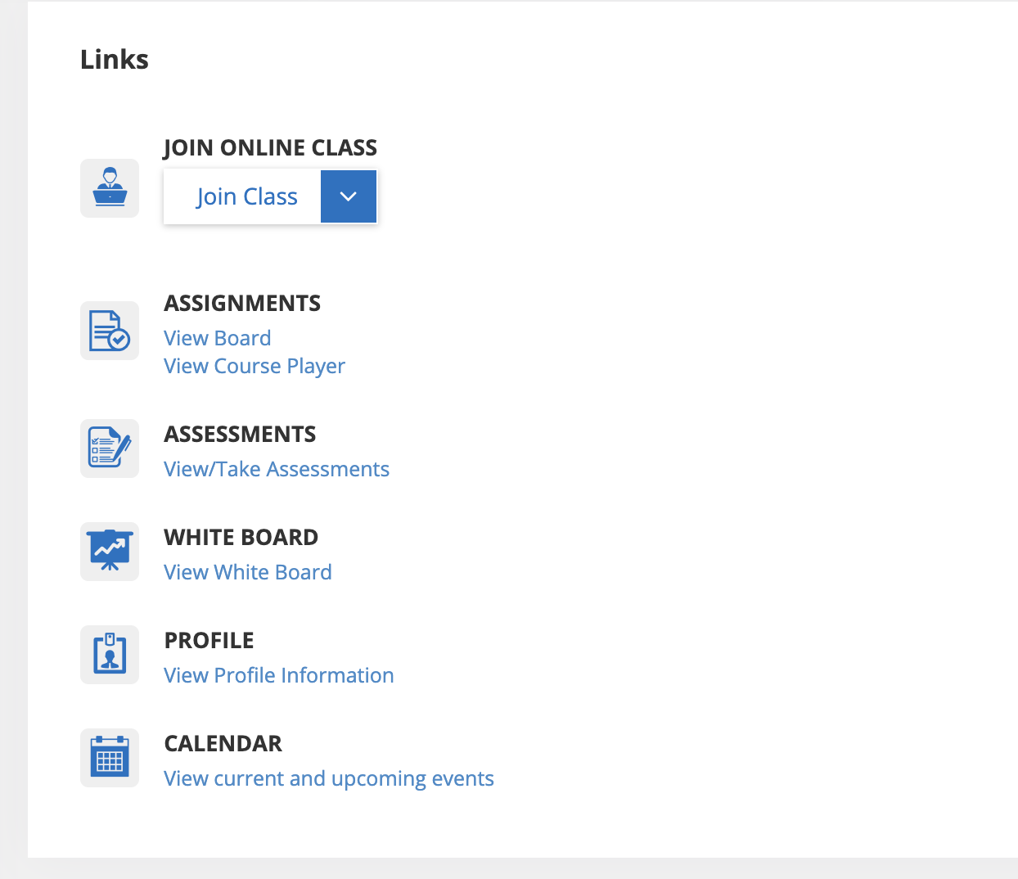

Contact us at hello@calimaticedtech.com for any questions.

### **Customizing The Platform**

Customize the platform to meet your branding & institute needs



Written By Ivan Karmer

Updated one year ago

The Platform provides several customization options to make it more streamlined to your needs. Get Started with some of the useful customizations:

1. [Branding](https://help-lcm.calimatic.com/article?categoryId=3&solutionId=150) (Setup your Branding on the Platform)
2. [Profile](https://help-lcm.calimatic.com/article?categoryId=3&solutionId=151) (Update the Profile details)
3. [Terminologies](https://help-lcm.calimatic.com/article?categoryId=3&solutionId=152) (Update the Platform Terminologies)
4. [Hierarchy Setup (for Classes, Courses, and Events)](https://help-lcm.calimatic.com/article?categoryId=3&solutionId=153) (Setup the Hierarchy to best organize your operations)
5. [Curriculum Form Fields](https://help-lcm.calimatic.com/article?categoryId=3&solutionId=154) (Customize the Form fields for Course, Level, etc)
6. [Security Permissions](https://help-lcm.calimatic.com/article?categoryId=3&solutionId=57) (Customize the Security Permissions for different roles)
7. [Attachments Permissions](https://help-lcm.calimatic.com/article?categoryId=3&solutionId=155) (Customize the Attachments Permissions for different roles)

If you need assistance with the setup, book your one-on-one session [here](https://calendly.com/calimatic/60min).

Contact us at hello@calimaticedtech.com for any questions.

### **Branding Changes**

Customize the platform to meet your branding needs



Written By Ivan Karmer

Updated 2 years ago

We understand the importance of Branding and how it helps improve your business. We provide ways to Brand the Web Platform and Mobile Apps.

1. Web Portal Logo and Login Page Image
2. Email Branding
3. Custom URL
4. Branded Mobile App

**Web Portal Logo and Login Page Image**

Login as Master Admin and navigate to Admin > System Config > Calimatic Platform Config. You have the ability to set

1. ***Web Portal Logo* -** In the Logo section, click on the “Choose Logo Image” button and upload your logo. You have the ability to set the background of the Logo by clicking on the “Menu Bar Logo Background” color picker and setting a color. Clicking the “Save Changes” button will log you out of the application and update the Logo across the Web Portal.
2. *Web Portal Login Image* **-** In the Login Image section, click on the “Choose login page Image” button and upload your image. Clicking the “Save Login Image” button will log you out of the application and update the Login Page image.

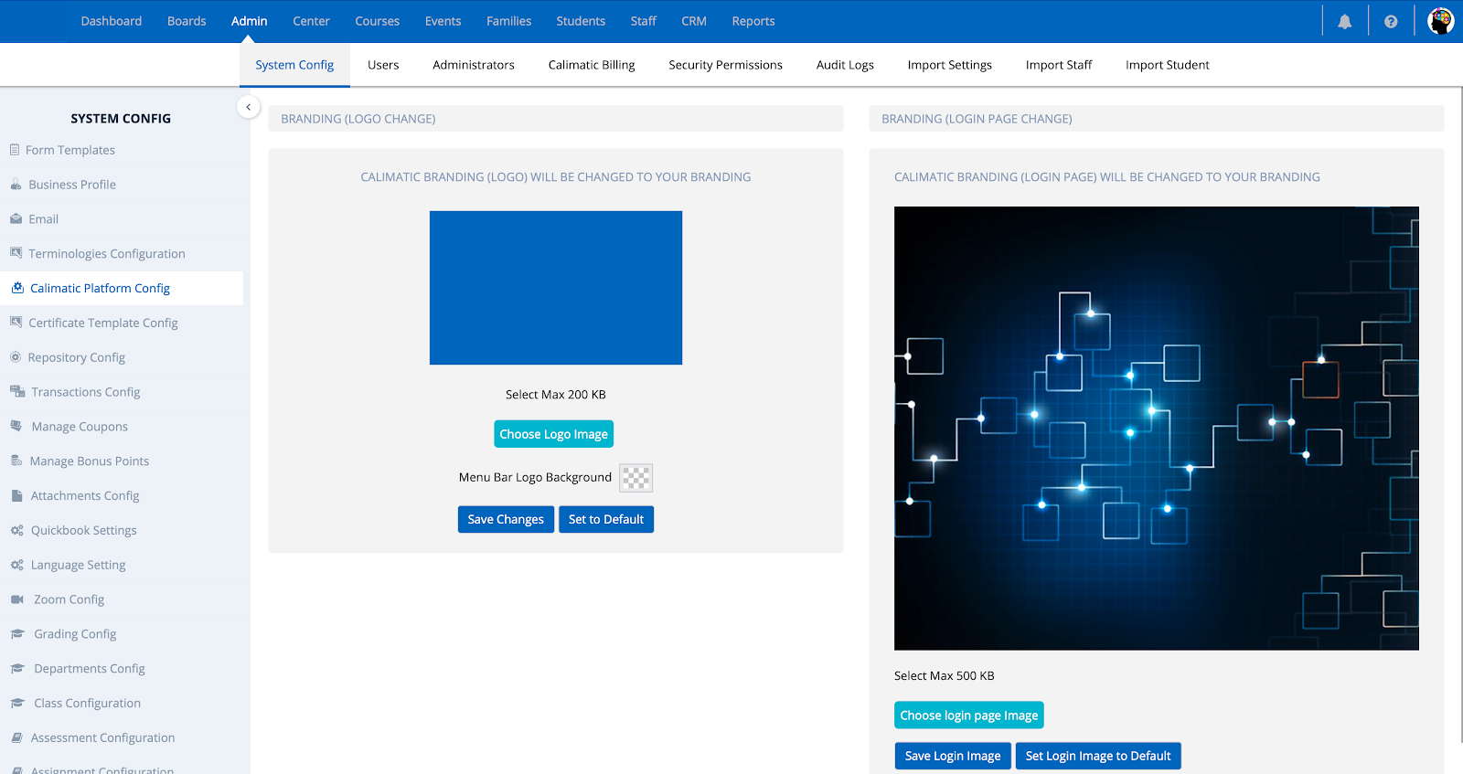

**Email Branding**

There are 2 types of emails that can be sent from the Platform. You have the ability to set some Branding for the Emails sent.

1. System or Transactional Emails
2. Marketing Emails

***System or Transactional Emails***These emails are Platform generated emails to inform about certain progress, status or other information. Example - Enrollment Emails, Student Progress Emails, etc.

1. **Email Footer:**

Login as Master Admin and navigate to Admin > System Config > Email. In the page, scroll down to the Email Footer section. You have the ability to update the content of the Email footer by updating the info in the editor.

Note: If you are using Franchise/Center Management, each Franchise/Center can have their own Email Footer. If you wish to use the same Email Footer for all Franchises/Centers then click on the “Sync Settings” button and set Auto Sync. This will override any Franchises/Centers email footer settings and use the Master Account Email Footer.

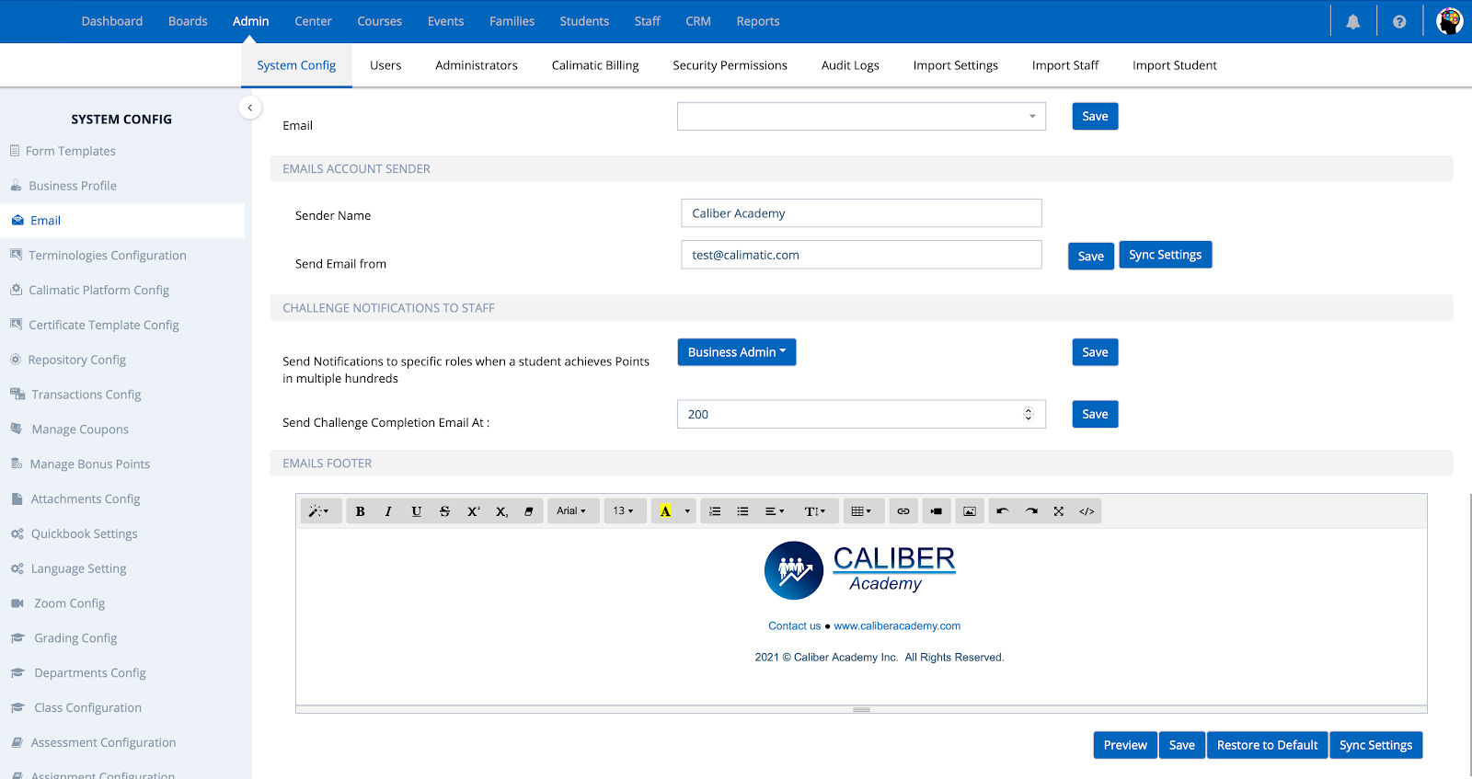

1. **Emails Account Sender:**

Login as Master Admin and navigate to Admin > System Config > Email. In the page, scroll down to the “Emails Account Sender” section.

Sender Name - Set this name if you wish to display the Email Account Sender name with your Institute name.

Send Email from - Set the email you wish to receive replies if the users send reply-to the emails that are sent from the Platform. At this point, all emails will be sent from “appteam@calimatic.com” to avoid sending emails to spam but the Email set here will be set for “reply-to” in the email headers.

Note: If you are using Franchise/Center Management, each Franchise/Center can have their own reply-to Email id. If you wish to use the same reply-to Email id for all Franchises/Centers then click on the “Sync Settings” button and set Auto Sync. This will override any Franchises/Centers reply-to email id and use the Master Account Email email id.

***Marketing Emails***

These emails are the emails that are generated from the CRM module.

Navigate to CRM > Emails > Templates.

In this page, you have the ability define your Email Templates and Email Footers. You have the ability to set your own Email Footers based on your brand and purpose.

**Custom URL**

A separate Database and Application Site is created for each Company that subscribes to Calimatic. The default url is in this format - https://<your-site-url>-lms.calimatic.com when you sign up for Calimatic. Send us the request to hello@calimaticedtech.com if you wish to have your own Custom URL, Fav icon and your standard page title.

**Branded Mobile App**

Calimatic LMS Mobile app is available on the Google Play Store and Apple App Store.

Contact us at hello@calimaticedtech.com if you wish to have your own Branded Mobile App with your Brand Logo, Colors and variants.

Contact us at hello@calimaticedtech.com for any questions.

### **Platform Accounts Structure**

Understanding and setting up the Accounts based on your need



Written By Ivan Karmer

Updated 2 years ago

This article describes different ways of setting up the Accounts and their best practices.

If your institute has only one entity, you can ignore Franchises or Centers setup. You can even remove the permissions to hide the Franchise/Center module or send us an email to hello@calimaticedtech.com to remove the module. In order to do this on your own, navigate to Admin > Security Permissions. Select a role, filter for Franchise word in Module column. Uncheck Grant Permissions and click on the Save icon (1st icon) above the grid.

For single entity, you will have the following structure (your main account is initially created will be the Master account by default) -

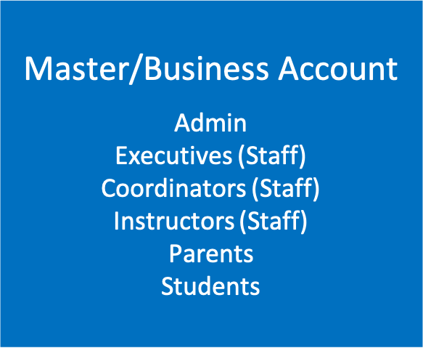

You can add users with different roles (like Executives, Coordinators, Instructors, Parents, Students). You can add users in Admin > Users page.

You can also add Staff (Executives, Coordinators, Instructors) in Staff > Staff Info page.

You can also add Parents and Students in Families > Families info page or Students > Students info page.

If your institute or business has multiple entities (like Franchises or Centers or Academies), there are 2 ways you can set up.

1) Your main account that is initially created will act as the Master Account. When you add Franchises/Centers in Franchises > Franchise Enrollments page, then each Franchise/Center will have a separate account. Under the Master account, as the Master Account Admin, you will have the ability to add users with different roles (like Executives, Coordinators). You can use this Master account to mainly manage the Operations, Content Creation & distribution to Franchises/Centers, managing Franchises, etc.

Under each Franchise account, the Franchise Account admin will have the ability to add users with different roles (like Executives, Coordinators, Instructors, Parents, Students).

You can add users with different roles (like Executives, Coordinators, Instructors, Parents, Students). You can add users in Admin > Users page.

You can also add Staff (Executives, Coordinators, Instructors) in Staff > Staff Info page.

You can also add Parents and Students in Families > Families info page or Students > Students info page.

Here is how the structure would look like -

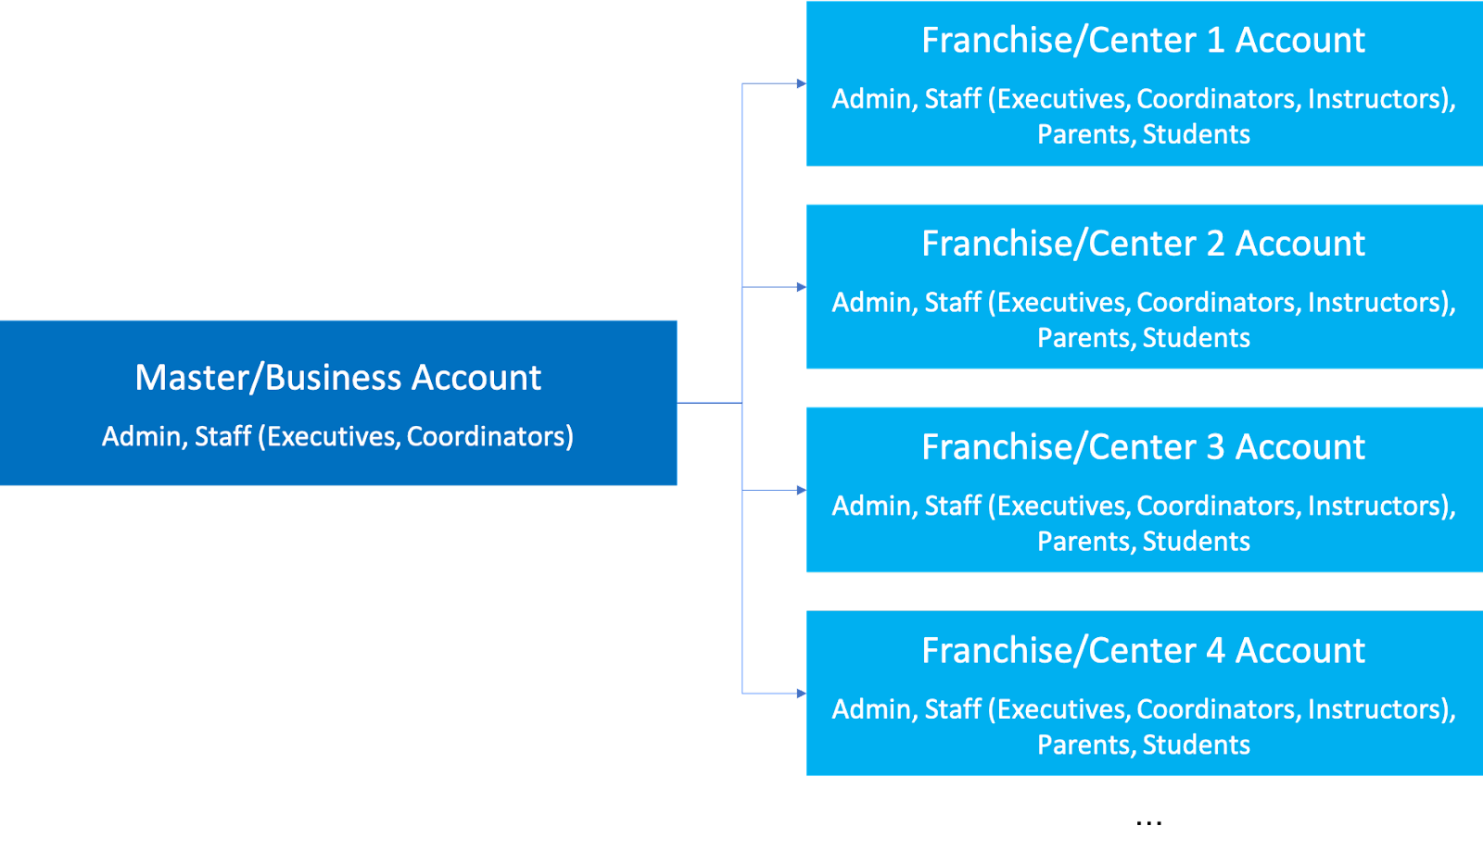

2) Your main account that is initially created will act as the Master Account. When you add Franchises/Centers in Franchises > Franchise Enrollments page, then each Franchise/Center will have a separate account. Under the Master account, as the Master Account Admin, you will have the ability to add users with different roles (like Executives, Coordinators). You can use this Master account to mainly manage the Operations, Content Creation & distribution to Franchises/Centers, managing Franchises, etc. And it can also be used as a regular institute or center to manage Students.

Under each Franchise account, the Franchise Account admin will have the ability to add users with different roles (like Executives, Coordinators, Instructors, Parents, Students).

You can add users with different roles (like Executives, Coordinators, Instructors, Parents, Students). You can add users in Admin > Users page.

You can also add Staff (Executives, Coordinators, Instructors) in Staff > Staff Info page.

You can also add Parents and Students in Families > Families info page or Students > Students info page.

Here is how the structure would look like -

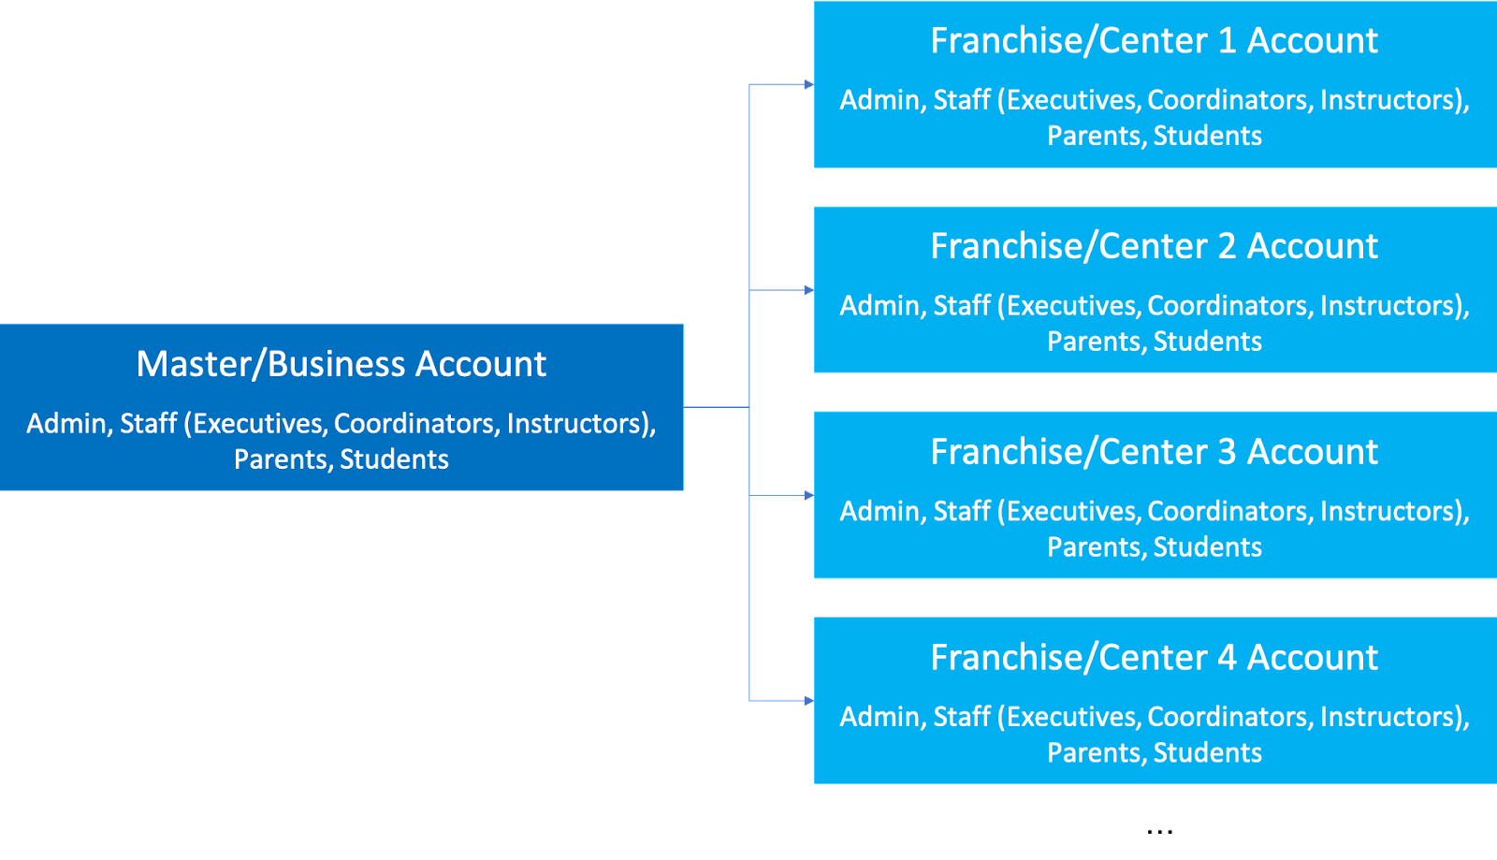

Contact us at hello@calimaticedtech.com for any questions.

### **Terminology Changes**

Update the Platform Terminologies based on your Business or Institute needs



Written By Ivan Karmer

Updated 2 years ago

The system provides the ability to update the Terminologies of the Platform to match your Business or Institute terminologies.

Login as Master Admin and navigate to Admin > System Config > Terminologies Configuration.

Here you have the ability to update the terminologies and the labels will be updated through out the platform.

Example - If you change Assessment label to Exam and click on "Update Label" then all the places where it displays as Assessment will be changed to Exam.

### **Payments Setup**

Setup Payment Gateways to receive money



Written By Ivan Karmer

Updated one year ago

The system provides the ability to accept payments in the following options:

**International Countries**

* [Stripe Payment Gateway](https://stripe.com/) (accepts Credit & Debit cards and any other mode that Stripe accepts)

**United States of America**

* [Stripe Payment Gateway](https://stripe.com/) (accepts Credit & Debit cards)
* [Plaid](https://plaid.com/) (for Bank Accounts or ACH - via Stripe)

**India**

* [RazorPay](https://razorpay.com/) (Any payment mode that RazorPay accepts)

**Stripe Setup**

If you don't have a Stripe account, navigate [here](https://dashboard.stripe.com/register) to create an account for free. Navigate to [Payouts](https://dashboard.stripe.com/settings/payouts) in your Settings to set up your bank details. You will need your Routing number and your account number. After following the instructions you will activate your account. After account application approval you will need to integrate Stripe API keys into our platform. First, navigate to the [API keys page](https://dashboard.stripe.com/account/apikeys) from your settings and make sure that the "View test data" switch is turned off to use the live account. For testing turn on the test data switch. Then, on the Calimatic platform from the *Admin* menu select *System Config* and navigate to *Transactions Config*. After entering the Account name in the Stripe Account Configuration section enter Stripe API keys and save. Once activated you will see the "Your account has been successfully connected" message on the screen.

If your institute has Franchises or Centers, you have the ability to have different Stripe accounts for each Franchise and have visibility to track all of them. To configure the Franchise/Center Payment system, from the *Admin* menu enter *System Config* and select *Transaction Config*. By clicking *Connect to Stripe* you will navigate to the Stripe setup page. By following the instructions on the screen you can connect your Stripe account and activate it to receive payments. Once activated you will see the "Your account has been successfully connected" message on the screen.

**Plaid Setup**

To receive secured payments through a Bank account read more information [here](https://help-lcm.calimatic.com/article?categoryId=3&solutionId=162).

**RazorPay Setup**

For Indian clients read more information to set up RazorPay [here](https://help-lcm.calimatic.com/article?categoryId=3&solutionId=163).

Contact us at hello@calimaticedtech.com for any questions.

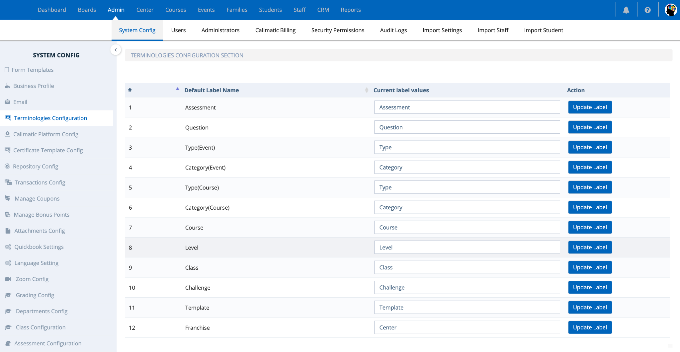

Contact us at hello@calimaticedtech.com for any questions.

### **Import Students, Parents, Staff & Leads**

Import your existing data (Students, Parents, Staff & Leads)



Written By Ivan Karmer

Updated one year ago

**1) Import Students to the Platform**

If you want to import Students Database, under the *Admin* menu enter *Import Student*. Attach the Excel file that has the list of Students and click *Import Excel Files Data* and follow the guide on the page.

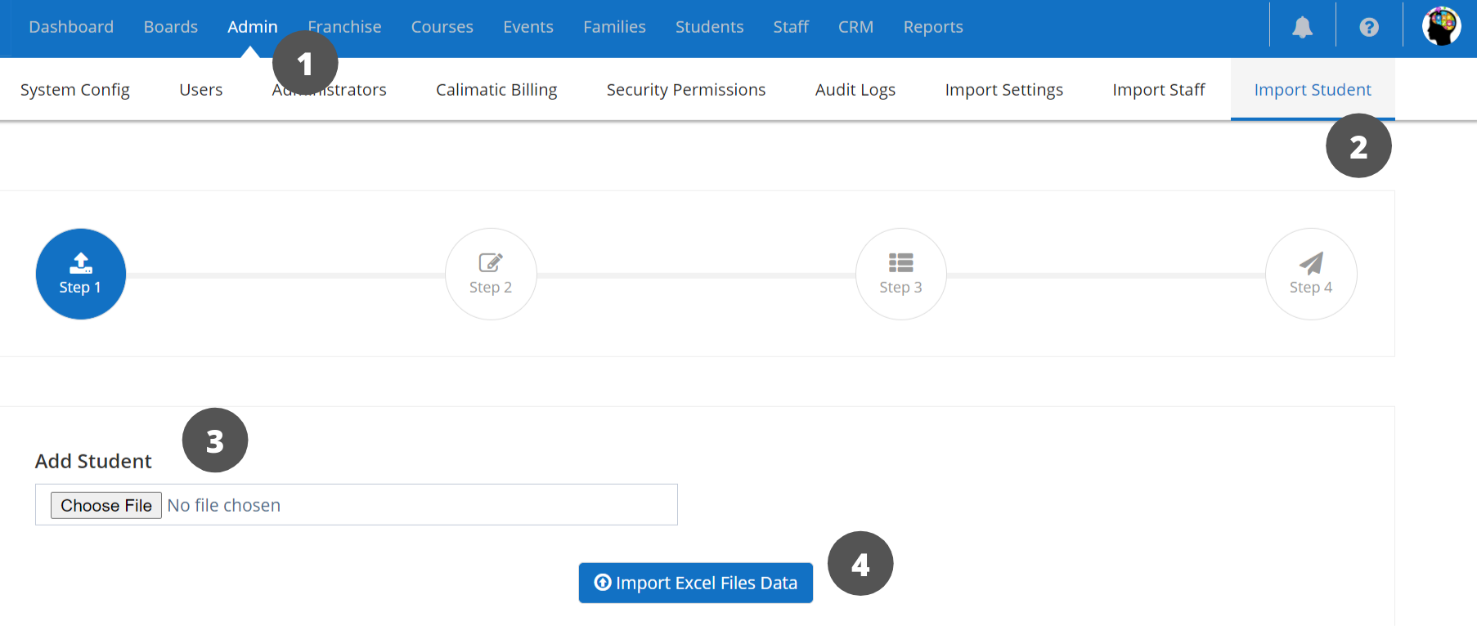

**2) Import Students & Parents (Contacts) to the Platform**

Under *Admin* menu and enter *Import Settings* page. After, attach the files, click *Import Excel Files Data* and follow the guide on the page.

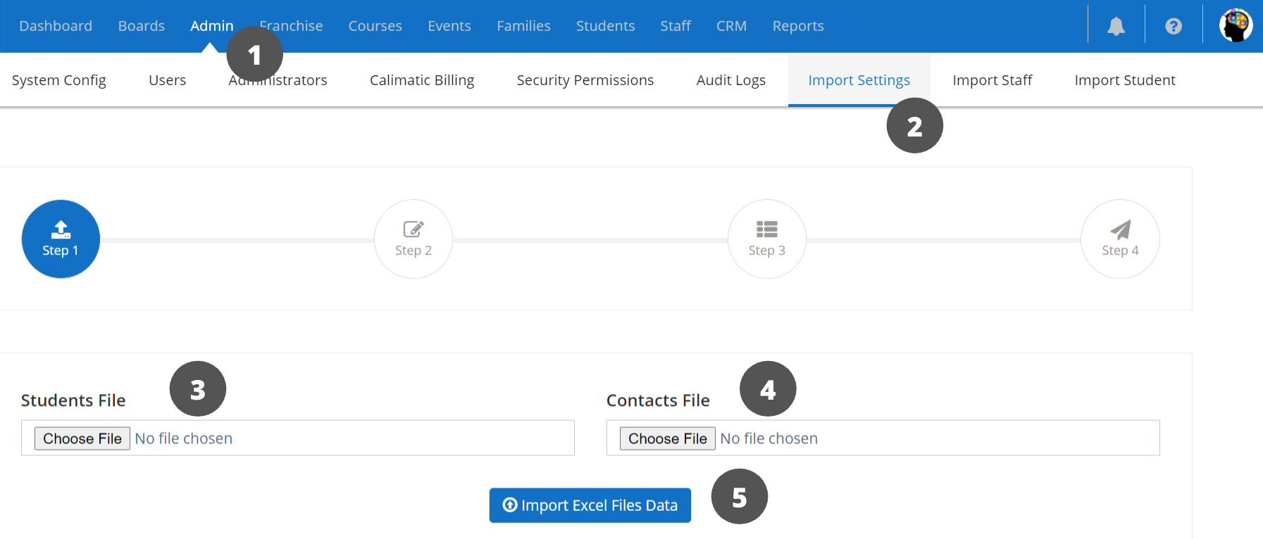

**3) Import Staff to the Platform**

Under *Admin* menu and enter *Import Staff* page. After, attach the files, click *Import Excel Files Data* and follow the guide on the page.

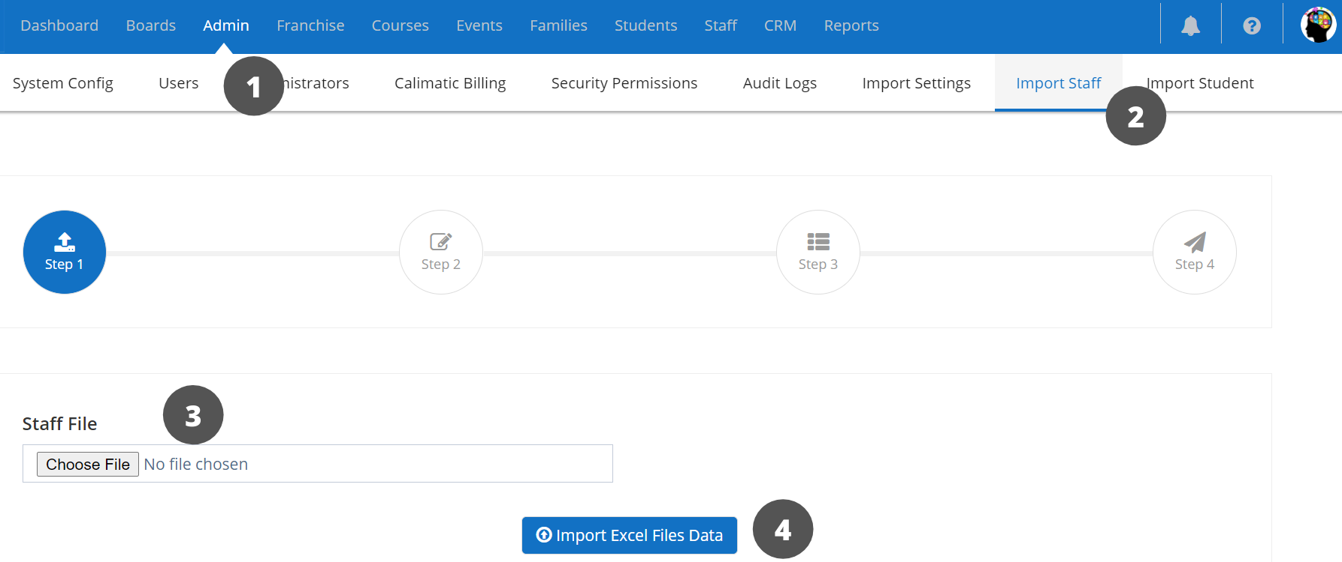

**4) Import Leads to the Platform**

Click on the CRM menu and click on the "Leads" submenu. Click on the “Add Leads” button and click on the “Import Leads” option.

In the popup, attach the Excel file that has the list of Leads. Click on the "Import Leads" button. Follow the next steps as instructed to complete the Import.

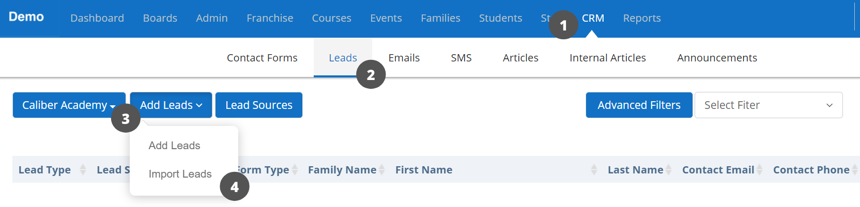

Contact us at hello@calimaticedtech.com for any questions.

### **Import Students And Parents**

Import bulk Students and Parents/Contacts into the Platform



Written By Scott Smith

Updated one year ago

The system provides the ability to import Students and Parents or Contacts into the system.

After you login, click on the “Admin” main menu and click on the “Import Settings'' submenu. You will be navigated to the import page.

There are 4 steps involved in importing the students and their contacts data into the system.

* In Step 1, upload the Microsoft excel file containing the students data under the “Students File” column, by clicking on the “Choose File” button.
  + After that, upload the Contacts data under the “Contacts File” column.
  + After uploading the files, click on the “Import Excel Files Data” button which will upload the data into the system and you will be navigated into the next step.
* In Step 2, you have to map the Column names of the excel file with the fields of the System. Example, the Family name column should map with the Family Field in the system.
  + After mapping the columns with the system fields, click on the “Continue” button and you will be navigated to the next step.
  + If there are any errors, the errors are displayed in Step 2.
  + Resolve the issues in the excel and navigate back to Step 1 to re-upload the excel.
  + Or you have the option to Ignore and continue with the Step.
* In Step 3, all the students in the excel sheets will be displayed in the grid.
  + Select the students and their corresponding Contacts or Parents you wish to import into the system.
  + You also have the ability to send portal access to the students by checking under the “Send Portal” column.
  + The Portal access will send emails to all the emails listed for the Students and Contacts.
  + They will have the ability to create the portal accounts from there.
  + After selecting the students, click on the “Import” button.
  + The students and their corresponding Contacts or Parents will be imported into the system and you will be navigated to the next step.
* In Step 4, you will be able to view the report of how many students and how many contacts are imported into the system successfully.

### **Import Staff**

Import Staff into the Platform



Written By Scott Smith

Updated one year ago

After you login, click on the “Admin” main menu and click on the “Import Staff” submenu. You will be navigated to the staff import page.

There are 4 steps involved in importing the staff data into the system.

* In Step 1, upload the Microsoft excel file containing the staff data under the “Staff File” column, by clicking on the “Choose File” button.
  + After uploading the files, click on the “Import Excel Files Data” button which will prepare the upload process and you will be navigated in the next step.
* In Step 2, you have to map the Column names of the excel file with the fields of the System. Example, the Email column should map with the Email Field in the system.
  + Note that the Security Role column should be included in your excel file.
  + One of the following Staff Role should be used as the Security Role - Business Executive, Business Coordinator, Business Instructor, Franchise Executive, Franchise Coordinator or Franchise Instructor.
  + After mapping the columns with the system fields, click on the “Continue” button and you will be navigated to the next step.
  + If there are any errors, the errors are displayed in Step 2. Resolve the issues in the excel and navigate back to Step 1 to re-upload the excel.
  + Or you have the option to Ignore and continue with Step3.
* In Step 3, all the Staff in the excel sheets will be displayed in the grid.
  + Review the list and click on the “Import” button.
  + The Staff will be imported into the system and you will be navigated to the next step.
* In Step 4, you will be able to view the report of how many staff are imported into the system successfully.

### **Security Permissions**

Manage permissions for your Users to control who can add/edit/view/delete



Written By Scott Smith

Created one year ago

The system provides the ability to set the permissions for different roles (their ability to view or make changes across different areas within the system).

**Navigation:-**

Login as Master admin and navigate to Admin > Security Permissions.

Select the role you wish to customize in the Security role dropdown list. By default, all the roles are given default permissions based on the common rules. You have the flexibility to update the permissions at any time.

The roles are divided into 2 categories - Business Roles and Franchise Roles.

All the users related to Master or Main Business or Head Quarters will fall under Business Roles. If your business or institute does not have any centers or franchises then all your users fall under Business Roles.

All the users related to Franchises or Centers fall under Franchise Roles.

After selecting the role a grid will appear. In the grid you have following options:-

* **“Module”** column represents the modules found in the system i.e: Admin, Boards, CRM etc.
* **“Page Permissions”** column represents different options found in the module.
* **“Function Permission”** column represents the function or flow of the options in the module.
* **“Page Action”** column contains checkboxes containing permissions for **“View”**, **“Add”**, **“Edit”** and **“Delete”** against the corresponding option and function of the module. You can check and uncheck the boxes which permissions you want to give to the role.
* **“Grant Permission”** column contains the grant all the permission function i.e: If you check the Grant Permission box all the permissions of **“View”**,**”Add”**,**”Edit”** and **“Delete”** are checked for that particular option and flow.

In order to save the permission settings click on the **“Save”** icon on the top left corner.

To select check all the permission boxes for the entire system click on the **“Select All”** icon on the top left corner.

To deselect, check all the permission boxes click on the **“Deselect all”** icon on the top left corner.

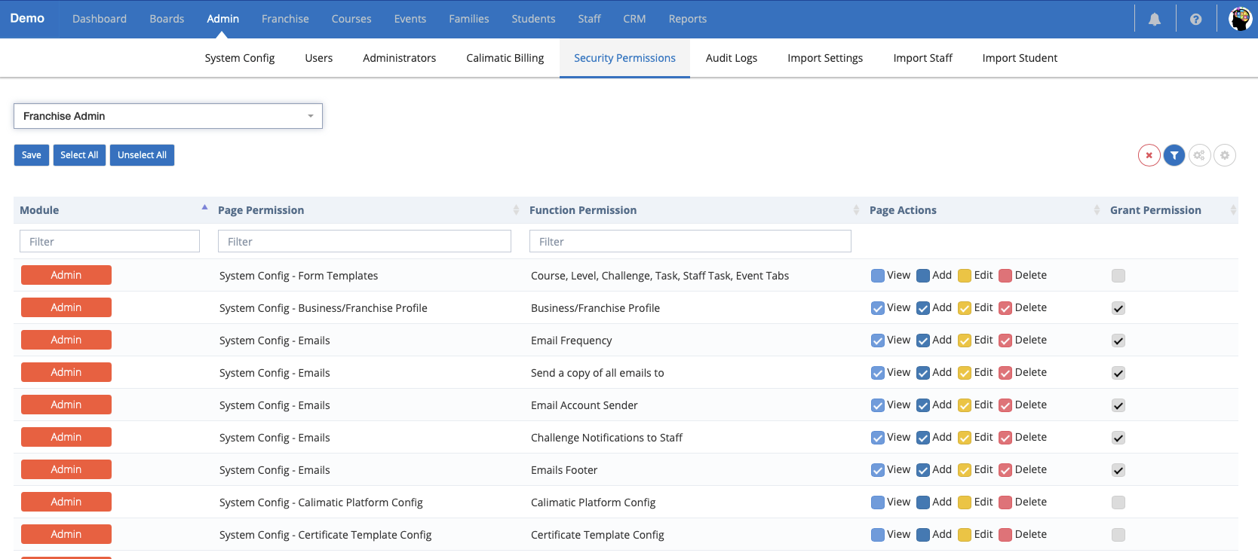

You have the ability to filter out the modules, page permissions etc by clicking on the **“Filter Icon”** on the right hand side

You have the ability to download the **Print, export to PDF or CSV** the permission list of a particular user by clicking on the “**Settings”** icon.

You have the ability to change the view of the grid to **“Compact”**, **“Default”** or **“Comfortable”** by clicking on the **“View Settings”** button.

Need assistance with the setup? Book your one-on-one session: <https://calendly.com/calimatic/60min>

Contact us at hello@calimaticedtech.com for any questions.

### **Setup Stripe For Online Payment Processing**

Steps to Setup Stripe Payment Gateway for Online Payment Processing



Written By Ivan Karmer

Updated 2 years ago

If you don't have a Stripe account already, navigate to<https://dashboard.stripe.com/register> (Create the account for Free).

Fill out the form to create an account for your business or institute and follow the steps to complete the creation.

Navigate to https://dashboard.stripe.com/settings/payouts to set up your Bank details to receive money.

You would need to have available your Routing number and your Account number. Fill out the blanks and then click on “Activate Account”.

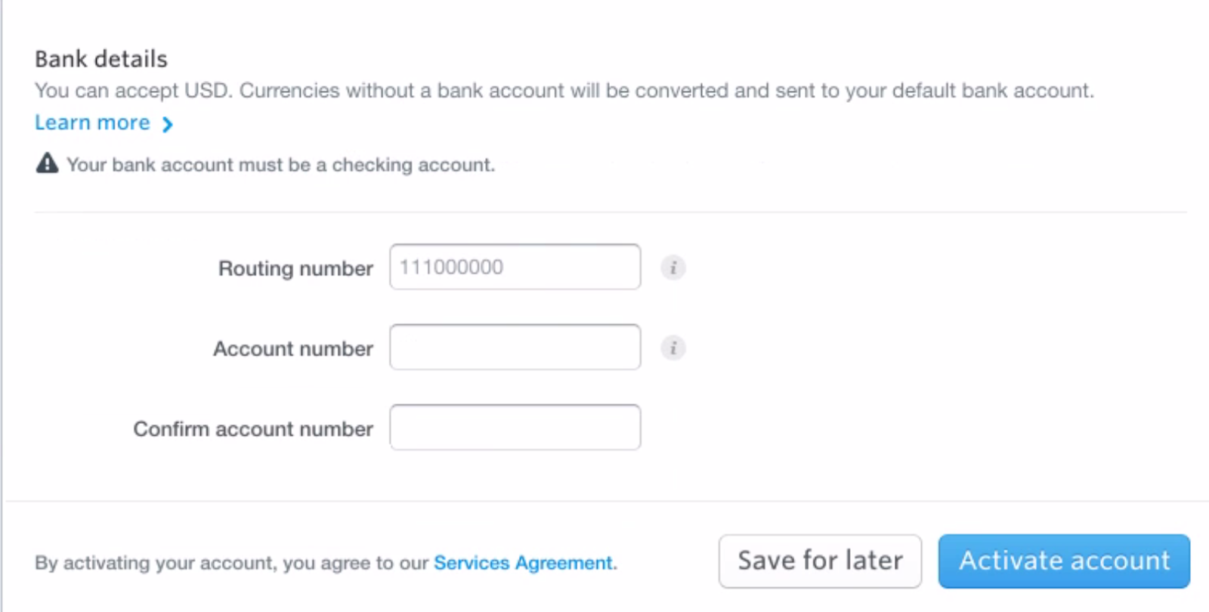

When your account application is approved, proceed with the below steps.

We need the API keys to integration with the Platform. Navigate to<https://dashboard.stripe.com/account/apikeys>

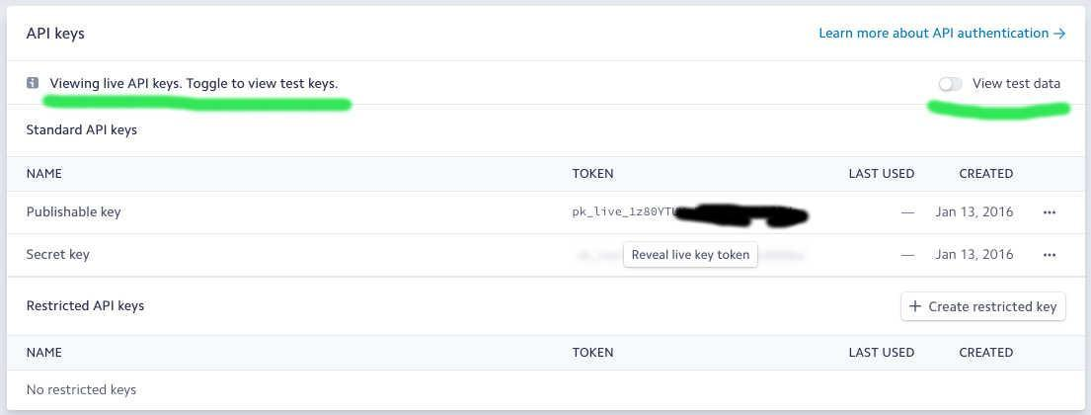

Ensure the "View test data" switch is turned off to use the live account. If you want to test, you can turn on the test data switch.

In order to integrate your Stripe Account with the Platform, click on Admin menu and System Config sub-menu in the Platform. Click on the "Transactions Config" menu in the left side section.

In the below screen, enter your desired Account Name in the Stripe Account Configuration section.

Enter the Stripe keys from your Stripe account. Click on Save. When the Platform is successfully connected, you will see the below shown successful message.

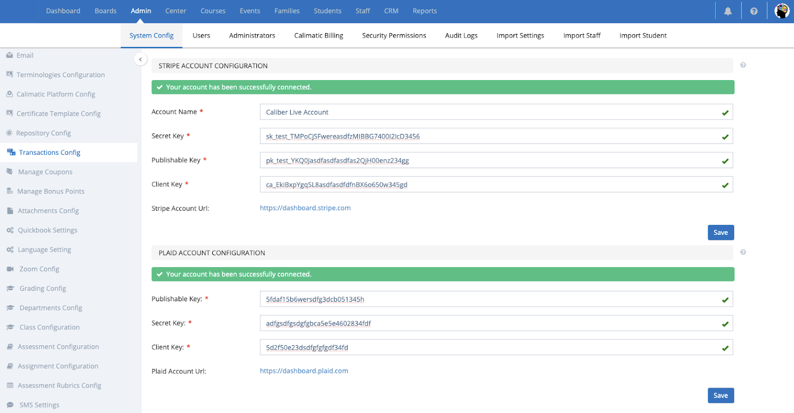

Contact us at hello@calimaticedtech.com for any questions.

### **Plaid Setup**

Setup Plaid for Bank Account or ACH Payments via Stripe



Written By Ivan Karmer

Updated 2 years ago

**Note:** Please [set up Stripe](https://help-lcm.calimatic.com/article?categoryId=3&solutionId=158) before setting up Plaid.

If you do not have a Plaid account, [create one](https://dashboard.plaid.com/signup). Follow the steps to complete the signup process. Plaid might request additional details via email. If you have any questions with answering their queries, please reach out to us (hello@calimaticedtech.com).

Enable integration to Stripe here by clicking on the Enable button for the Stripe -<https://dashboard.plaid.com/team/integrations>

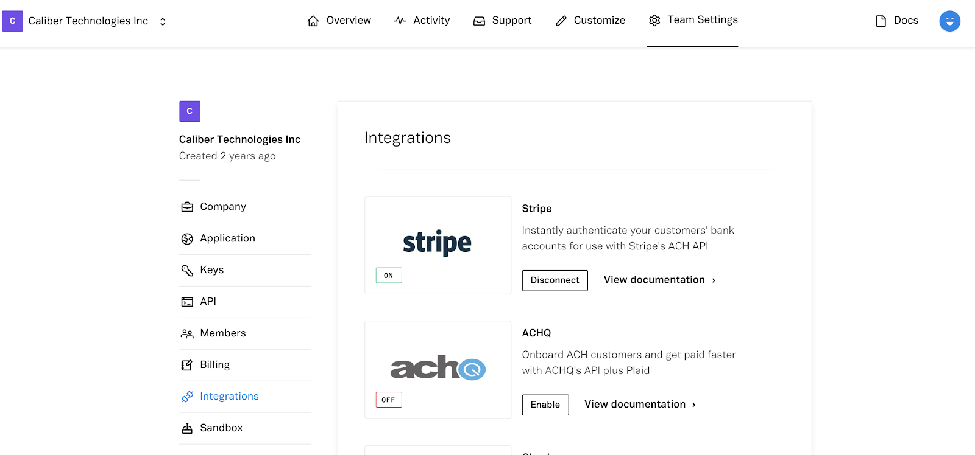

You will need to copy the keys from Plaid into the Calimatic Platform.

To get keys from Plaid, navigate to<https://dashboard.plaid.com/team/keys>

To enter keys into the Calimatic Platform, Click on Admin menu and click on System Config submenu. Click on the “Transactions Config” menu in the left side section of the page.

Copy “client_id” from Plaid and enter into “Client Key” in Calimatic under the Plaid section.

Copy “public_key” from Plaid and enter into “Publishable Key” in Calimatic under the Plaid section.

Copy “Production” key under Secrets from Plaid and enter into “Secret Key” in Calimatic under the Plaid section.

Click on the Save button and check for the successful message.

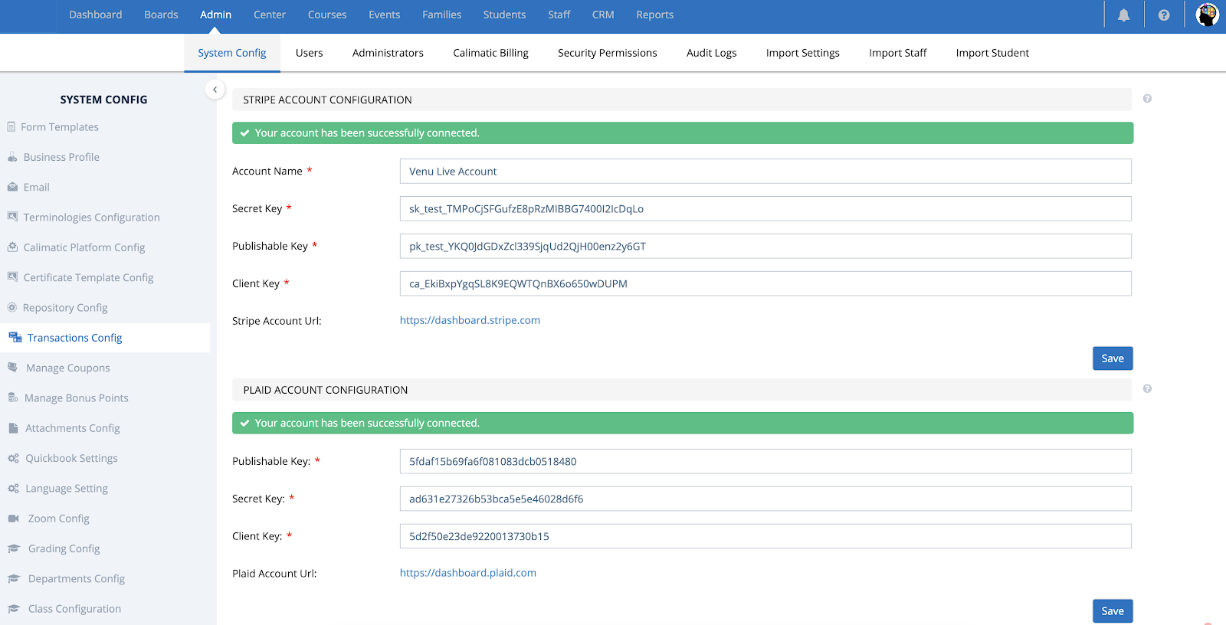

Contact us at hello@calimaticedtech.com for any questions.

### **RazorPay Setup**

Setup RazorPay to receive Payments in India



Written By Ivan Karmer

Created 2 years ago

If you don't have a RazorPay account already, navigate to<https://dashboard.razorpay.com/signup> (Create the account for Free).

Fill out the form to create an account for your business or institute and follow the steps to complete the creation, activation of your account and setting your account to Live mode.

Navigate to<https://dashboard.razorpay.com/app/keys>

Click on Generate Live Key.

You will need to copy the keys from RazorPay into the Calimatic Platform.

To enter keys into the Calimatic Platform, Click on Admin menu and click on System Config submenu. Click on the “Transactions Config” menu in the left side section of the page.

Copy “Key Id” from Plaid and enter into “Key Id” in Calimatic.

Copy “Key Secret” from Plaid and enter into “Key Secret” in Calimatic.

Click on the Save button to connect to RazorPay.

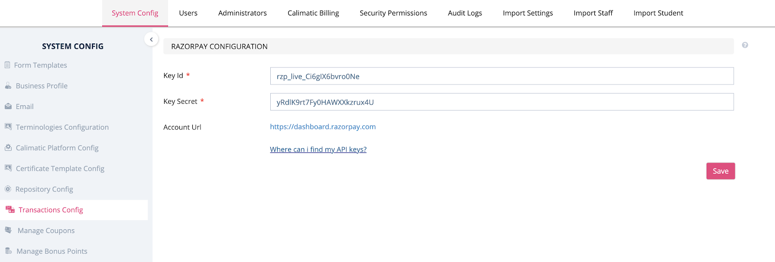

Contact us at hello@calimaticedtech.com for any questions.

### **Business Profile Changes**

Update your Business Profile details



Written By Ivan Karmer

Updated 2 years ago

Master Admin has the ability to update and maintain the Business Profile details.

Navigate to Admin > System Config > Business Profile.

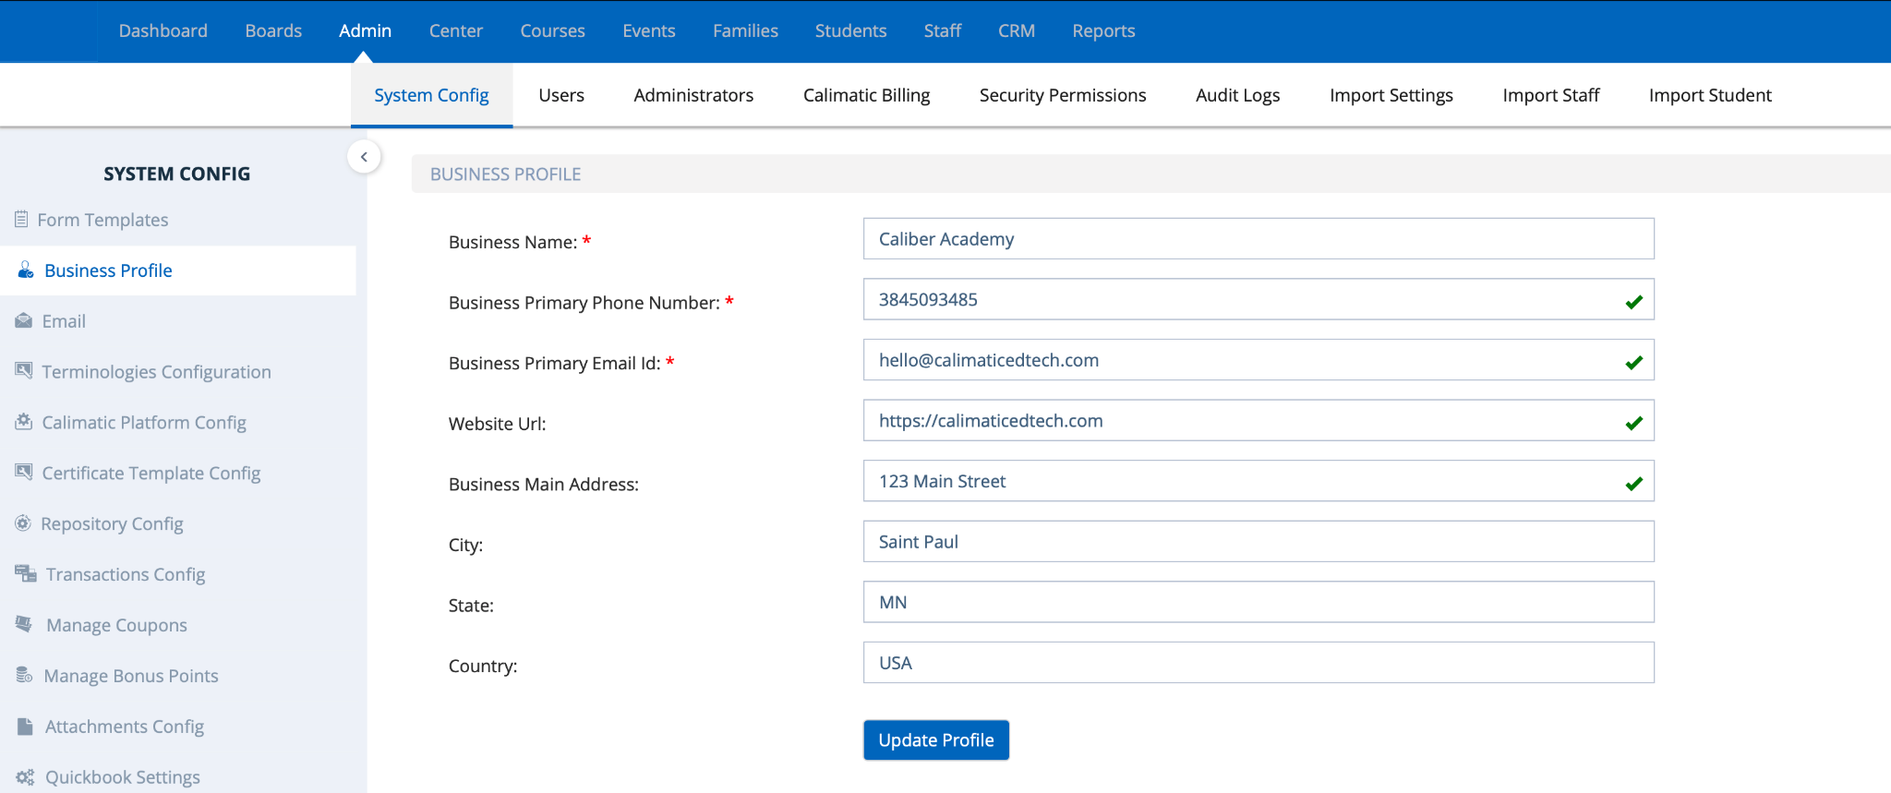

Currently the Business Profile information is not used in any functionalities but it is helpful to have this information with up to date for us.

Contact us at hello@calimaticedtech.com for any questions.

### **Hierarchy Setup (For Classes, Courses And Events)**

Setup the Structure to seamlessly handle multiple ways of your Classes, Courses and Events



Written By Ivan Karmer

Updated 2 years ago

Before you start creating the Courses, Classes or Events, it is helpful for you to go through the Hierarchy Setup.

The system provides the ability to set up in a simple way or in a way to scale up more easily.

You can directly create Courses and setup classes for the Courses

or you can set up Class Types, Class Categories and set up Courses for the corresponding Types or Categories.

Here is an example Hierarchy setup -

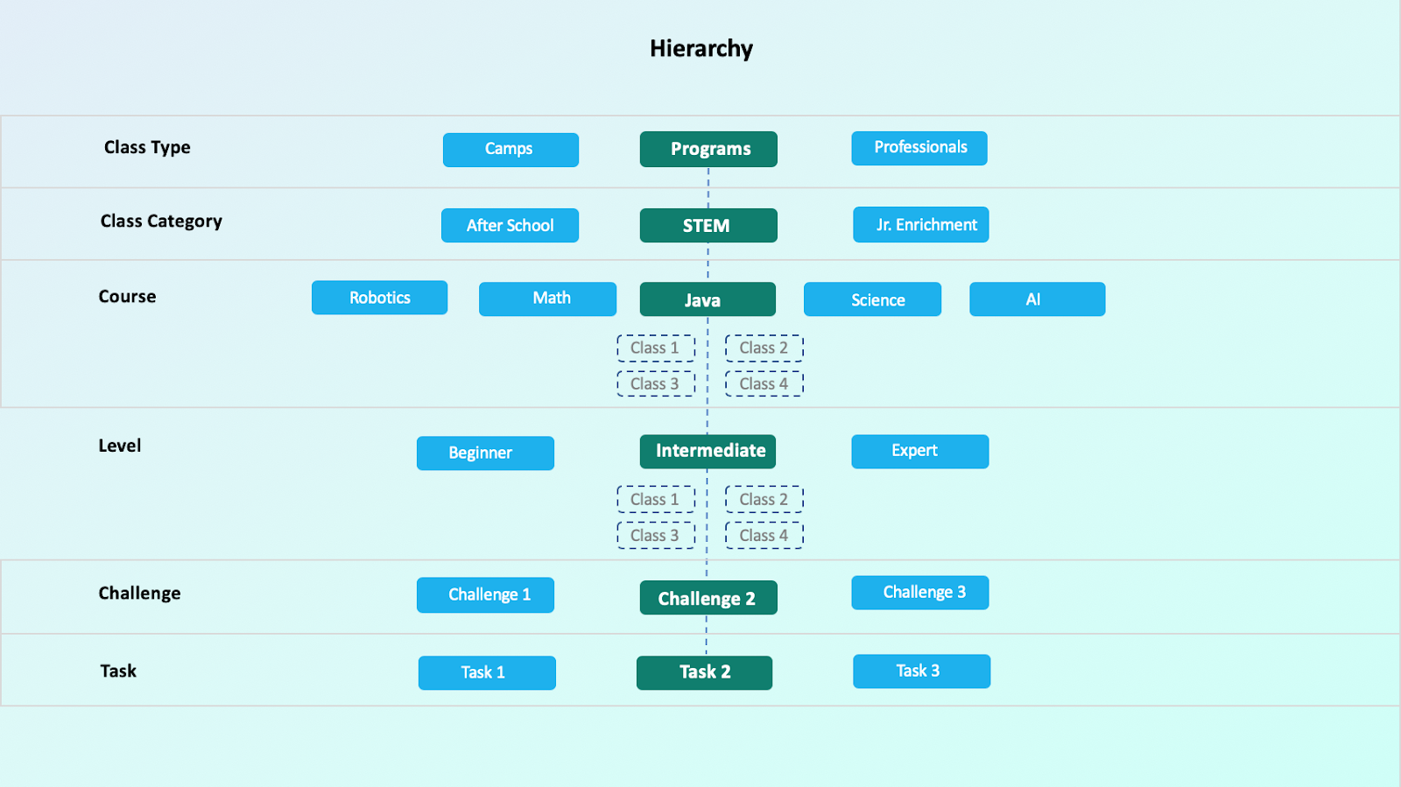

Follow the below steps for the Hierarchy Setup -

1. [Class Types](https://help-lcm.calimatic.com/article?categoryId=10&solutionId=91)
2. [Class Categories](https://help-lcm.calimatic.com/article?categoryId=10&solutionId=92)
3. [Event Types](https://help-lcm.calimatic.com/article?categoryId=11&solutionId=117)
4. [Event Categories](https://help-lcm.calimatic.com/article?categoryId=11&solutionId=118)

Once the Types and Categories are setup, you can use them in

1. [Courses Setup](https://help-lcm.calimatic.com/article?categoryId=4&solutionId=61)
2. [Classes Setup](https://help-lcm.calimatic.com/article?categoryId=10&solutionId=90)
3. [Events Setup](https://help-lcm.calimatic.com/article?categoryId=11&solutionId=116)

Need assistance with the setup? Book your one-on-one session:<https://calendly.com/calimatic/60min>

Contact us at hello@calimaticedtech.com for any questions.

### **Curriculum Form Fields**

Add or Manage fields in the Curriculum Forms (like Courses, Levels, Topics/Challenges, etc)



Written By Ivan Karmer

Updated 2 years ago

The system provides the ability to customize the default Curriculum forms by updating existing fields or adding new fields.

Login as Master Admin and navigate to Admin > System Config > Form Templates.

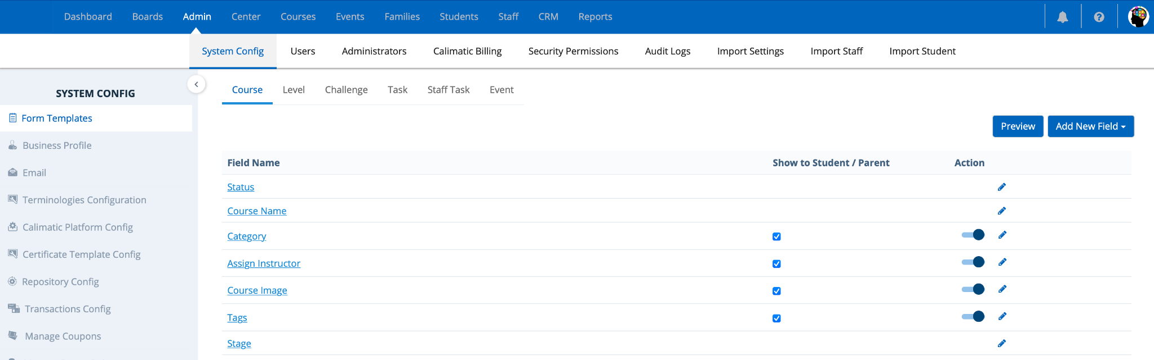

By default, you are navigated to the Course tab as shown above. All the fields that are displayed for the course are listed here.

For each of the field, you have the ability to enable or disable the field in the action column by selecting the switch. If it is disabled then the field will not be displayed.

Clicking on the edit icon in the action column will provide the ability to update the properties of the field.

"Show to Student / Parent" column provides the ability to set the permission if the field needs to be displayed to the parent & student.

Clicking on the "Add New Field" button will open up the drop down list where you can select an option to create the appropriate field.

In the Fields list, you have the ability to reorder the fields.

Need assistance with the setup? Book your one-on-one session: <https://calendly.com/calimatic/60min>

Contact us at hello@calimaticedtech.com for any questions.

### **Attachments Permissions**

Manage the Permissions of the Attachments in Curriculum and White Boards



Written By Ivan Karmer

Created 2 years ago

The system provides the ability to control the permissions of the attachments on who can Add, View, Download or Delete in Curriculum and White Boards.

**Navigation:** Login as Master Admin and navigate to Admin > System Config > Attachments Config.

The permissions are primarily handled for 3 types/areas - General Files, Code Files, White Board Files.

Selecting "General Files" in the Attachment Type dropdown list will display Course, Level and Challenge sections.

Each of the section will display the list of roles and following columns -

* “User Role” column has all the user roles available in the system i.e: Business Admin, Business Executive, Franchise Admin etc.
* “Add” column gives you the ability to set permission for adding an attachment against a specific role.
* “View” column gives you the ability to set permission for adding an attachment against a specific role.
* “Download” column gives you the ability to set permission for adding an attachment against a specific role.
* “Delete” column gives you the ability to set permission for adding an attachment against a specific role.  
  Based on the selection, the permissions will be set. User will need to logout and login back to see the changes.

In the same way, you have the ability to set permissions for Code Files and White Board Files.

Contact us at hello@calimaticedtech.com for any questions.

### **Google Drive Configuration**

Configuration to integrate with Google Drive



Written By Ivan Karmer

Updated one month ago

## **How to setup Google Drive?**

First go to Google Cloud console and create a new project or select the existing project.

## **API Key**

## 1) Go to the [API Console](https://console.cloud.google.com/apis/dashboard)

## 2) From the projects list, select a project or create a new one.

## 3) If the APIs & services page isn't already open, open the left side menu and select **APIs & services**.

## 4) On the left, choose **Credentials**.

## 5) Click **Create credentials** and then select **API key**.

## 

## **OAuth Client Id & API Secret Key**

## 1) In the Google Cloud console, go to Menu menu > **APIs & Services** > **Credentials**.

## 2) Click **Create Credentials** > **OAuth client ID**.

## 3) Click **Application type** > **Web application**.

## 4) In the **Name** field, type a name for the credential. This name is only shown in the Google Cloud console.

## 5) Add authorized URIs related to your app:

## a) **Client-side apps (JavaScript)**–Under **Authorized JavaScript origins**, click **Add URI**. Then, enter a URI to use for browser requests. This identifies the domains from which your application can send API requests to the OAuth 2.0 server.

## b) **Server-side apps (Java, Python, and more)**–Under **Authorized redirect URIs**, click **Add URI**. Then, enter an endpoint URI to which the OAuth 2.0 server can send responses.

## 6) Click **Create**. The OAuth client-created screen appears, showing your new Client ID and Client secret.

## 7) Click **OK**. The newly created credential appears under **OAuth 2.0 Client IDs**.

## 

## Once you have all of your keys (Api Key, Api Secret Key, Client Id), Login to your website & go to > Admin > system config > Google Drive config, enter all keys & press save.

### **Dropbox Configuration**

Configuration to integrate with Dropbox



Written By Ivan Karmer

Updated one month ago

## **How to setup DropBox?**

To use the Dropbox API, you'll need to register a new app in the [App Console](https://www.dropbox.com/developers/apps).

## **API Key & Api Secret Key**

## 1) Create a new app by clicking on the **Create App** button dropbox app console.

## 2) Click on **Choose an Api** option.

## 3) Click on **Choose the type of access you need option.**

## a) App folder– Access to a single folder created specifically for your app.

## b) Full Dropbox– Access to all files and folders in a user's Dropbox.

## 4) Give any **Name to your app**.

## 5) Click on the **Term & Condition** check box.

## 6) Then click on the **Create App** button.

## 7) The newly created api key and api secret key appears.

## Once you have all of your keys (Api Key). Login to your website & go to > Admin > system config > Dropbox config, enter key & press save.

### **Zoom Integration Configuration**

Configuration setup to integrate with Zoom video conference



Written By Ivan Karmer

Updated one month ago

Go to [https://marketplace.zoom.us](https://marketplace.zoom.us/) and setup your ZOOM account.

The Server to Server OAuth App is required to configure zoom:

**Server to Server OAuth**

* Once you setup your account Go to the > Solutions Tab > App Marketplace
* Once you’re in App Marketplace > Click on Develop > Build App
* Once you’re in the Build App area, Click on > Server-to-Server OAuth Section & click on ‘create’
* Give your app a name & fill in all the details & click on continue.
* Once you continue you will find your ACCOUNT ID, CLIENT ID and CLIENT SECRET, copy all the keys and click on continue

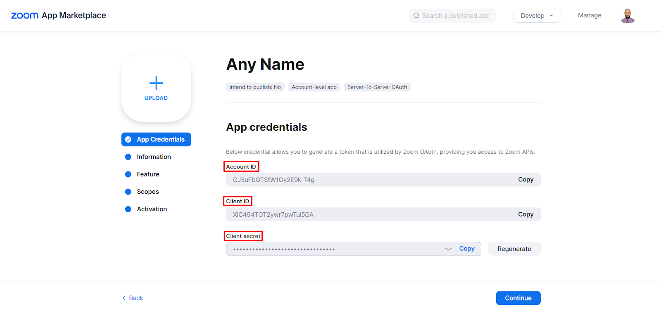

* You can use these keys to configure ZOOM on your calimatic
* Simply, go to Admin > System Config > Zoom Config and Save your keys

